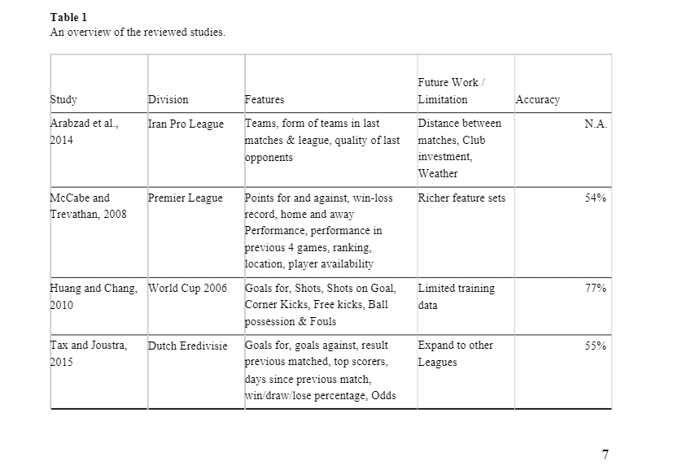

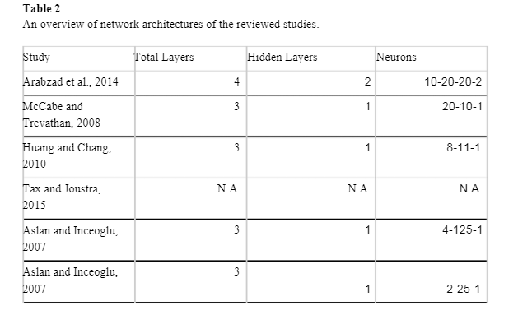

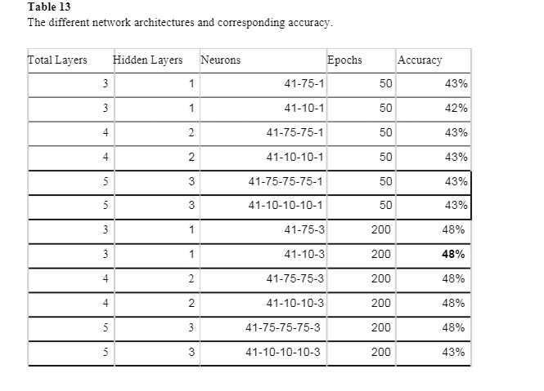

<https://www.researchgate.net/publication/334415630_Football_Result_Prediction_by_Deep_Learning_Algorithms#pf6>

Bayesian Neural Network

The average human soccer expert has 60–65% accuracy in predicting results

[4] McCabe, Alan, and Jarrod Trevathan. “Artificial Intelligence in Sports Prediction.” *IEE Xplore*, <https://ieeexplore.ieee.org/stamp/stamp.jsp?arnumber=4492661.> <https://ieeexplore.ieee.org/document/4492661?denied=>

“Football is the most watched, popular sport in the world. The English Premier League is the most popular league in the world. The English clubs playing in the PL have an annual TV rights deal worth over $9 billion, which is the highest paid licensing contract in sports at present. The PL is most followed by billions around the world not only because of its recognition and the big name players playing there, but it’s widely renowned for the sheer uncertainty that it carries. In 2015-2016 season, Leicester City FC came out on top winning against all odds. The betting odds for Leicester winning the PL title were 1/66000 which shows the unpredictability of this league and the results associated with it.”

Igiri et al. [9] extracted data from 110 matches played in the 2014 and 2015 English Premier League season and used as input to a neural network system. The features used are: Home and Away goals (GHA), Home and Away shots (HAS), Home and Away corners (HAC), Home and Away Odds (HAOD), Home and Away attack strength (HAAT), Home and Away Players’ performance index (HAPPI), Home and Away Managers’ performance index (HAMPI), Home and Away streak (HASTK), Home and Away managers’ win (HAMW). They used 20 matches played in 10th and 11th week of 2014/15 English Premier League to predict the outcomes. The result was 85% accuracy using Logistic Regression, optimizing features by weighting.

[9] Igiri, Chinwe Peace and Nwachukwu, Enoch Okechukwu (2014), “An Improved Prediction System for Football a Match Result”, IOSR journal of Engineering 4 (12): 12-20.

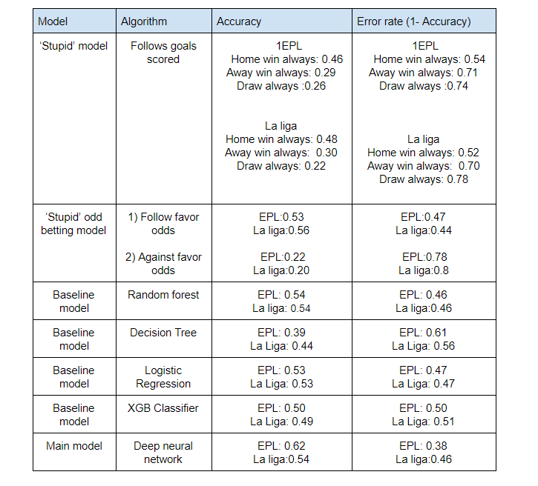

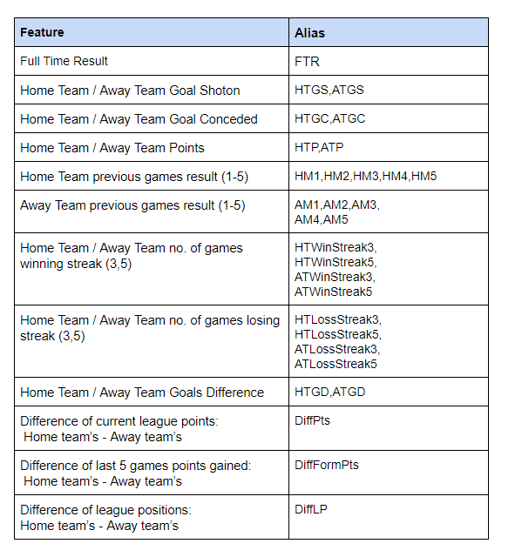<https://medium.com/@rolandshum.shc/neural-networks-football-result-prediction-d8b0f933118b>

**My Own Table**

Average human soccer expert has 60-65% chance to predict right outcome

|  |  |  |  |
| --- | --- | --- | --- |
| **Source** | **League** | **Features** | **Accuracy** |
| A. McCabe and J. Trevathan, "Artificial Intelligence in Sports Prediction," *Fifth International Conference on Information Technology: New Generations (itng 2008)*, Las Vegas, NV, 2008, pp. 1194-1197, doi: 10.1109/ITNG.2008.203. | Premier League | Points for and against, win-loss record, home and away Performance, performance in previous 4 games, ranking, location, player availability | 54% |
| Tax, N., Joustra, Y.P., Predicting the Dutch football competition using public data: A machine learning approach, Trans. Knowl. Data Eng. | Dutch Eridivisie | Goals for, goals against, result previous matched, top scorers, days since previous match, win/draw/lose percentage, Odds | 55% |
| Aslan, B., & Inceoglu, M. (2007). A Comparative Study on Neural Network Based Soccer Result Prediction. Seventh International Conference on Intelligent Systems Design and Applications | Italian Serie A | Home rating & Away rating for home team and away team | 51% & 53% |
| Samba, Stefan. (2019). Football Result Prediction by Deep Learning Algorithms. 10.13140/RG.2.2.25014.45122. | Premier League | referee, odds for a home win, draw or away win by 6 bookmakers, season and division and results | 53% |